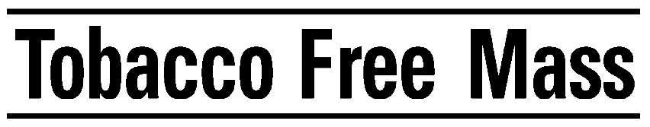

2021 TOBACCO FREE MASS MEETING SCHEDULE

Quarterly full coalition meetings
Zoom registration link:
https://us02web.zoom.us/meeting/register/tZUtdOutrT0tGdDJNjt1KObXCYZOhDCLVSYC
Location: Massachusetts Medical Society, Waltham. Note that we will not meet in person until at least July 2021.

Thursday, March 4 – 10:00 AM to Noon
Thursday, June 3 – 10:00 AM to Noon
Thursday, September 9 – 10:00 AM to Noon
Thursday, December 2 – 10:00 AM to 12:00 PM

Advocacy Committee Meetings
Zoom registration link:
https://us02web.zoom.us/meeting/register/tZIocu6uqzMtGtKMNO_Uo8cuDyLg1R5oops_
Location: September and December at Massachusetts Medical Society. All others: Strategy Group, 40 Court Street, Boston. Note that we will not meet in person until at least July 2021.

Thursday, January 21 – 10:00 AM to 11:30 AM
Thursday, March 4 – 12:15 PM to 1:30 PM (following full coalition meeting)
Thursday, April 15 – 9:30 AM to 10:30 AM
Thursday, June 3 – 12:15 PM to 1:30 PM (following full coalition meeting)
Thursday, July 22 – 9:30 AM to 10:30 AM
Thursday, September 9 – 12:15 PM to 1:30 PM (following full coalition meeting)
Thursday, October 21 – 9:30 AM to 10:30 AM
Thursday, December 2 – 12:15 PM to 1:15 PM (following full coalition meeting)

Executive Committee meetings
Location: Strategy Group, 40 Court Street, Boston. Note that we will not meet in person until at least July 2021.

Thursday, February 25 – 10:00 AM to 11:30 AM
Thursday, May 13 – 10:00 AM to 11:30 AM
Thursday, August 5 – 10:00 AM to 11:30 AM
Thursday, November 18 – 10:00 AM to 11:30 AM

