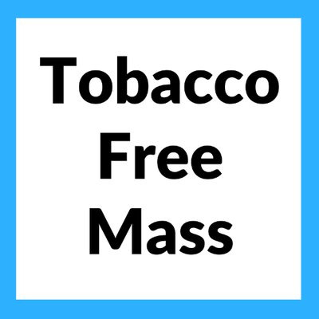
Establishing Sustainable Funding for Tobacco Prevention and Cessation Programs

WHY WE NEED INCREASED FUNDING
To help save lives, it is critical for sustainable funding for state tobacco prevention and cessation programs to reach levels that meet or exceed the Centers for Disease Control and Prevention’s (CDC) recommendations. The Massachusetts Tobacco Cessation and Prevention Program (MTCP) is critical to the fight against tobacco in Massachusetts. It implements and enforces laws, including the Smokefree Workplace Law, the flavored sales ban, and other emerging concerns like density issues. The program funds local boards of health and community organizations to do enforcement and education, runs the state’s Quitline, implements communications campaigns, and provides surveillance and evaluation for tobacco issues, including e-cigarette use among young people. Much of the funding for this program ultimately ends up in cities and towns across the Commonwealth. Increased funding will allow the tobacco program to address emerging issues while continuing its current innovative and essential work. This work would focus on CDC’s best practices, to reduce tobacco use and make smoking not the norm, incorporate the following:
- Community Programs, including youth led initiatives;
- Statewide Programs, including increasing funding for local boards of health;
- Cessation Programs, including the Quitline and outreach to key constituencies;
- Counter Marketing efforts and
- Surveillance and Evaluation

Tobacco is the leading cause of preventable illness and premature death in MA
- Tobacco use remains the leading cause of preventable death, killing more than 9,300 people in Massachusetts each year.¹
- Kids now under 18 and alive in Massachusetts who will ultimately die prematurely from smoking, 103,000.¹

Tobacco use takes a huge financial toll on the economy
- The CDC estimates that in Massachusetts, tobacco use costs an estimated $4.08 billion in health care costs each year, including approximately $1.26 billion in state Medicaid expenditures.¹

In Conclusion
Ideally MA would use the Master Settlement Agreement (MSA) and/or other tobacco tax revenue to fully fund tobacco control programs that follow CDC best practices. Over 20 years since the MSA settlement, we continue to underfund the tobacco control and prevention program in the Commonwealth. Revenue generated from increased state tobacco taxes and appropriations from general revenue can serve as an additional source of funding for MTCP.

For more information, please contact
Allyson Perron Drag at Allyson.Perron@heart.org or Marc Hymovitz at Marc.Hymovitz@cancer.org

1. Youth projected to die prematurely: The Health Consequences of Smoking: 50 Years of Progress. A Report of the Surgeon General, 2014.

